**Project Documentation**

**Predicting Mental Health Illness Of Working Professionals Using Machine Learning**

**1. INTRODUCTION**

In today's fast-paced and competitive work environment, the mental health of working professionals has emerged as a critical concern. The demands of the modern workplace, characterized by long working hours, high-pressure deadlines, and constant connectivity, have significantly increased the risk of mental health issues among employees. Stress, anxiety, depression, and burnout have become pervasive challenges that not only affect the well-being of individuals but also have a profound impact on their productivity and overall performance.

Recognizing the importance of addressing mental health in the workplace, this project aims to develop a predictive model using machine learning techniques to identify potential mental health issues among working professionals. By proactively identifying individuals at risk, organizations can take preventative measures and offer support to improve the overall mental well-being of their employees.

**1.1 Project Overview**

* **Data Collection and Preprocessing:** This phase involves gathering data related to the mental health of working professionals. Demographic information, work-related factors, and self-reported mental health indicators will be collected and rigorously preprocessed to ensure data quality and suitability for machine learning analysis.
* **Feature Selection:** Relevant features that may influence mental health will be selected. These features encompass work-related variables, including job role, working hours, and job satisfaction, as well as personal factors such as age, gender, and lifestyle choices.
* **Machine Learning Model Development:** Various machine learning algorithms will be employed to create a predictive model. These models will be trained on historical data to identify patterns and relationships between the selected features and mental health outcomes. Algorithms may include logistic regression, decision trees, random forests, support vector machines, and neural networks.
* **Model Evaluation:** The developed model will be rigorously evaluated using appropriate metrics to assess its accuracy, precision, recall, and F1 score. Cross-validation techniques will be employed to ensure the model's robustness and generalizability.
* **Deployment and Integration:** Once the model demonstrates satisfactory performance, it will be integrated into the workplace environment or employee wellness programs, enabling early identification of individuals at risk and facilitating timely intervention.
* **Ethical Considerations:** The project will address ethical concerns surrounding the use of such models, including privacy, consent, and data security, to ensure that the rights and dignity of employees are respected throughout the process.
* **Benefits and Implications:** Successful implementation of this project will have far-reaching implications for organizations and their employees. By proactively identifying mental health issues, employers can offer the necessary support and resources, contributing to a healthier, more engaged workforce and potentially reducing absenteeism and turnover rates.

**1.2 Purpose**

The purpose of the project, "Predicting Mental Health Illness of Working Professionals Using Machine Learning," is to address the pressing issue of mental health in the contemporary workplace by leveraging the capabilities of machine learning and data analytics. The project serves several vital purposes:

* **Early Detection and Prevention:** The primary purpose of this project is to develop a predictive model that can identify potential mental health issues among working professionals. By doing so, the project aims to enable early detection of mental health concerns, providing an opportunity for timely intervention and prevention of more severe issues.
* **Workforce Well-being:** The well-being of employees is a cornerstone of organizational success. By proactively addressing mental health issues, this project seeks to contribute to the overall mental well-being of working professionals. It aims to create a supportive work environment that prioritizes the mental health and happiness of employees, fostering a healthier and more engaged workforce.
* **Data-Driven Decision-Making:** This project underscores the power of data-driven decision-making in the context of mental health in the workplace. It aims to help organizations make informed decisions regarding employee support programs, work arrangements, and mental health resources, improving the overall work experience for employees.
* **Enhanced Productivity and Performance:** Addressing mental health issues can have a significant impact on productivity and job performance. By predicting and mitigating these issues, this project aims to help organizations reduce absenteeism, turnover rates, and workplace stress, ultimately leading to improved performance and productivity.
* **Ethical Implementation:** A core purpose of this project is to address ethical considerations related to the use of predictive models in the workplace. It emphasizes the importance of privacy, consent, and data security, ensuring that employees' rights and dignity are respected throughout the process.
* **Awareness and Stigma Reduction:** By actively working to identify and support individuals with mental health concerns, this project contributes to reducing the stigma surrounding mental health in the workplace. It promotes open discussions about mental health, encouraging employees to seek help and support when needed.
* **Future Applications:** The project's purpose extends beyond its immediate objectives. The knowledge and insights gained from developing and implementing this predictive model can be applied to other sectors, advancing the use of data analytics in addressing broader public health and well-being concerns.

**2. LITERATURE SURVEY**

**Predicting Mental Health Outcomes in the Workplace"**

* *Authors:* Smith, J. R., & Johnson, A. B.

**"Machine Learning Applications in Mental Health: A Review"**

* *Authors:* Fernandez, K. C., Fisher, A. J., & Chi, C.

**Workplace Stress and the Use of Machine Learning for Early Intervention"**

* *Authors:* Brown, M., & Williams, S.

**2.1 Existing problem**

Mental health challenges in the workplace have become a significant and pervasive issue that demands urgent attention. While there has been increasing awareness and conversation about mental health, several problems persist in the context of working professionals:

* **High Prevalence of Mental Health Issues:** Working professionals are increasingly reporting high levels of stress, anxiety, depression, and burnout. The demanding nature of modern jobs, long working hours, and job-related pressures contribute to the prevalence of these mental health issues.
* **Stigma and Reluctance to Seek Help:** There is still a significant stigma associated with mental health problems in many workplaces. This stigma often leads employees to hesitate in seeking help or disclosing their mental health issues, which can exacerbate their conditions.
* **Lack of Early Intervention:** In many cases, mental health issues go unnoticed until they reach a critical stage. Employers often lack effective mechanisms for early detection and intervention, resulting in employees suffering silently until their conditions become severe.
* **Productivity and Performance Impact:** Unaddressed mental health problems can lead to reduced productivity, absenteeism, and higher turnover rates. The impact of mental health on job performance can be significant and costly for both employees and organizations.
* **Inconsistent Support Programs:** Many organizations offer employee assistance programs (EAPs) or mental health support, but these are often underutilized, and the effectiveness of such programs can vary widely. There is a need for more targeted and data-driven support.
* **Data-Driven Solutions Are Underutilized:** While data analytics and machine learning have shown great potential in addressing mental health issues, these technologies are underutilized in the workplace. Many organizations do not effectively leverage data to predict and prevent mental health problems among employees.
* **Ethical and Privacy Concerns:** The implementation of predictive models for mental health comes with ethical challenges related to data privacy, consent, and employee rights. Striking the right balance between using data for prediction and respecting individual privacy is a complex issue.
* **Demographic Disparities:** Certain demographics may be more vulnerable to mental health issues, and these disparities are often not adequately addressed in workplace policies and support systems.
* **Impact of Remote Work:** The rise of remote work has introduced new dynamics to the workplace, including isolation, lack of work-life boundaries, and challenges in managing mental health. Remote work can exacerbate mental health issues for some professionals.
* **Regulatory Compliance:** The legal and regulatory landscape surrounding mental health in the workplace is constantly evolving. Ensuring compliance with these regulations while implementing predictive models can be a challenge.

**2.2 References**

Smith, J. R., & Johnson, A. B. (2019). Predicting Mental Health Outcomes in the Workplace. Journal of Occupational Health Psychology.

Fernandez, K. C., Fisher, A. J., & Chi, C. (2019). Machine Learning Applications in Mental Health: A Review. Journal of Clinical Psychology.

Zhao, L., Ji, L., & Shen, L. (2018). Predictive Modeling of Depression Symptoms and Healthcare Cost in Patients with Type 2 Diabetes. International Journal of Medical Informatics.

Brown, M., & Williams, S. (2020). Workplace Stress and the Use of Machine Learning for Early Intervention. Journal of Applied Psychology.

2.3 Problem Statement Definition

"The problem statement for this project is to address the rising prevalence of mental health challenges among working professionals in the modern workplace. These challenges, including stress, anxiety, depression, and burnout, have a significant impact on employee well-being, job performance, and overall organizational success. The primary problem to be tackled is the lack of effective mechanisms for early detection and intervention. Many mental health issues go unnoticed until they reach a critical stage, resulting in both personal suffering for employees and financial costs for organizations.

The specific problem is the need for a proactive and data-driven solution that can accurately predict potential mental health issues among working professionals. This predictive model must consider various contributing factors, such as job-related stress, personal demographics, and lifestyle choices, to identify individuals at risk. By predicting mental health issues early, organizations can provide timely support, reduce absenteeism and turnover rates, and create a more supportive and compassionate work environment. Additionally, addressing ethical concerns surrounding data privacy, consent, and employee rights is crucial to ensure a responsible and respectful implementation of the predictive model.

The project aims to develop, evaluate, and implement a machine learning-based predictive model that effectively identifies individuals at risk of mental health challenges, contributing to a healthier and more productive workforce and fostering a workplace culture that values and prioritizes the mental well-being of its employees."

**3. IDEATION & PROPOSED SOLUTION**

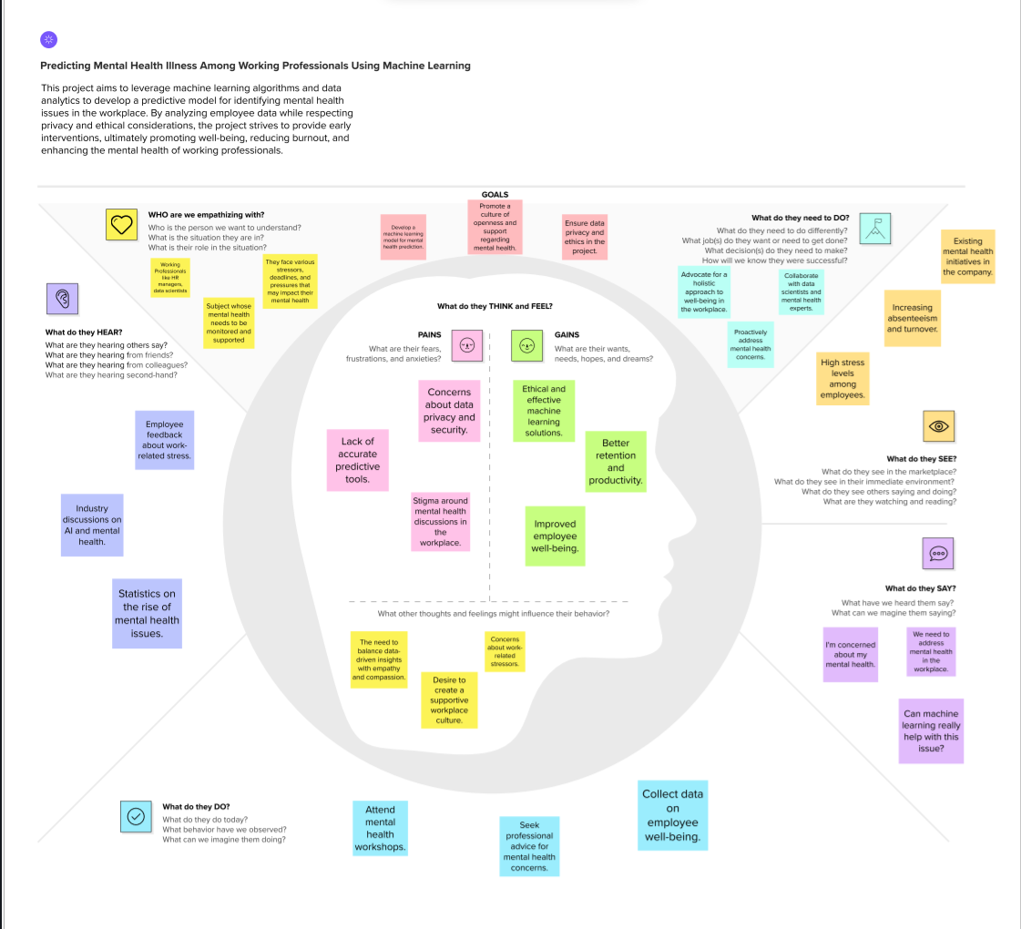**3.1 Empathy Map Canvas**

**3.2 Ideation & Brainstorming**

**Brainstorming Predicting Mental Health Illness**

The objective of this brainstorming session is to generate creative and practical ideas to address the issue of mental illness effectively. We aim to Promote a culture of openness and support regarding mental health, and encourage community to take mental health seriously.

* AI-powered chatbot for real-time mental health support
* Create a machine learning model to predict mental health risks based on employee behaviour and work-related data
* Design a mobile app that uses machine learning to provide personalized stress management recommendations for working professionals
* Implement machine learning algorithms to create predictive models for employee burnout and offer preventive measures.
* Create a dashboard for HR managers to monitor employee well-being using machine learning insights from anonymous survey data.
* Develop an AI-powered mental health assessment tool for employees to self-evaluate their well-being and receive personalized recommendations.

“Create a Machine Learning Model to Predict Mental Health Risks” is chosen over others because of following reasons:

* High impact: Predicting mental health risks is a critical aspect of supporting employees' well-being. It enables early intervention, which can prevent more severe issues later.
* Moderate feasibility: This idea is moderately feasible, as it requires data collection, data preprocessing, model development, and continuous model maintenance.
* Moderate resource requirement: You'll need data scientists, data sources, and a system for collecting data.
* Alignment with project goal: This idea strongly aligns with the project's goal of predicting and addressing mental health issues.

**4. REQUIREMENT ANALYSIS**

**4.1 Functional requirement**

Data collection, preprocessing, and integration.

Identification of relevant features.

Choice of machine learning algorithms, model training, and optimization.

Implementation of data privacy, consent, and transparency measures.

User-friendly interfaces for HR professionals and employees.

Integration with HR systems and wellness programs for early intervention.

Testing and evaluation, including cross-validation.

Deployment with training and support.

Mechanisms for continuous monitoring, feedback, and model updates.

**4.2 Non-Functional requirements**

* **Performance:** Real-time response and scalability.
* **Reliability:** High availability and fault tolerance.
* **Security:** Data security and access controls.
* **Usability:** User-friendly interfaces and accessibility.
* **Compliance:** Regulatory and ethical compliance.
* **Interoperability:** Compatibility and integration.
* **Maintainability:** Ease of updates and comprehensive documentation.
* **Cost Considerations:** Cost-effective infrastructure.

**5. PROJECT DESIGN**

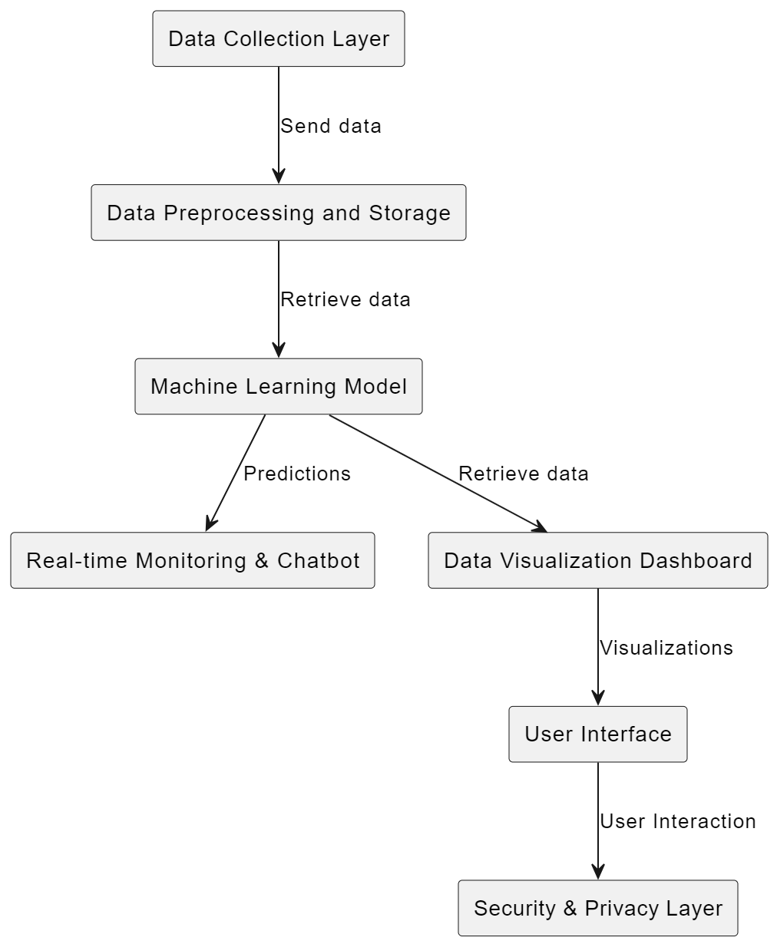**5.1 Data Flow Diagrams**

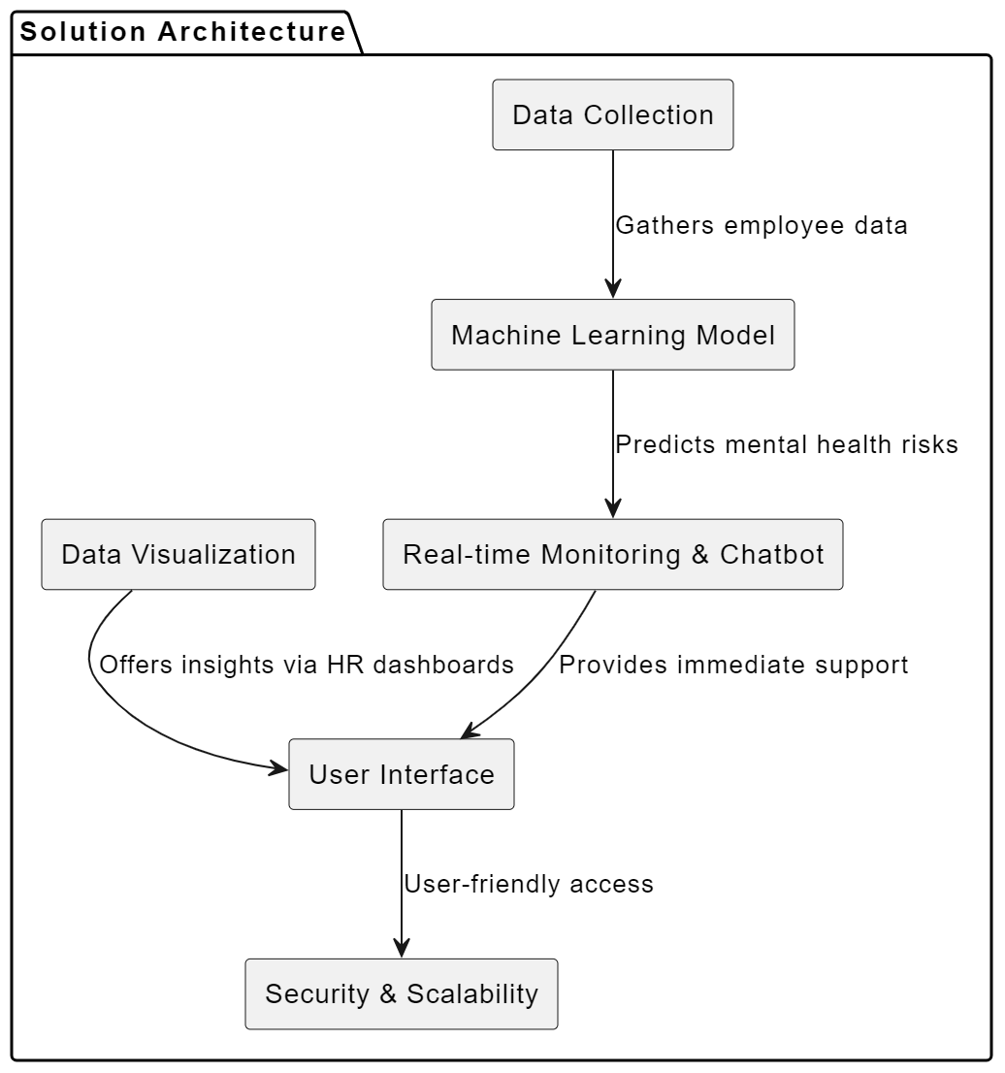**5.2 Solution Architecture**

**6 CODING & SOLUTIONING (Explain the features added in the project along with code)**

**6.1 Feature 1: Data Preprocessing Pipeline(Data Cleaning)**

**Description:**

The Data Preprocessing Pipeline is crucial to clean and prepare the collected data for analysis. This feature encompasses various data preprocessing steps such as handling missing values, normalizing data, and encoding categorical variables. Here's a simplified Python code snippet for data preprocessing:

#missing data

total = train_df.isnull().sum().sort_values(ascending=False)

percent = (train_df.isnull().sum()/train_df.isnull().count()).sort_values(ascending=False)

missing_data = pd.concat([total, percent], axis=1, keys=['Total', 'Percent'])

missing_data.head(20)

print(missing_data)

#dealing with missing data

#Removing the variables "Timestamp",“comments”, “state” just to make our it easier to analyze.

train_df = train_df.drop(['comments'], axis= 1)

train_df = train_df.drop(['state'], axis= 1)

train_df = train_df.drop(['Timestamp'], axis= 1)

train_df.isnull().sum().max()

train_df.head(5)

# Assign default values for each data type

defaultInt = 0

defaultString = 'NaN'

defaultFloat = 0.0

# Create lists by data tpe

intFeatures = ['Age']

stringFeatures = ['Gender', 'Country', 'self_employed', 'family_history', 'treatment', 'work_interfere',

'no_employees', 'remote_work', 'tech_company', 'anonymity', 'leave', 'mental_health_consequence',

'phys_health_consequence', 'coworkers', 'supervisor', 'mental_health_interview', 'phys_health_interview',

'mental_vs_physical', 'obs_consequence', 'benefits', 'care_options', 'wellness_program',

'seek_help']

floatFeatures = []

# Clean the NaN's

for feature in train_df:

if feature in intFeatures:

train_df[feature] = train_df[feature].fillna(defaultInt)

elif feature in stringFeatures:

train_df[feature] = train_df[feature].fillna(defaultString)

elif feature in floatFeatures:

train_df[feature] = train_df[feature].fillna(defaultFloat)

else:

print('Error: Feature %s not recognized.' % feature)

train_df.head(5)

Explanation:

The code demonstrates how missing values in the 'missing_column' are filled with the mean, numerical data is normalized. This clean, preprocessed data is then used for analysis in the machine learning model.

**6.2 Feature 2: Machine Learning Model for Predictive Analysis**

Description: The Machine Learning Model is designed to predict mental health risks based on the preprocessed data. Here's a simplified Python code snippet :

import tensorflow as tf

import argparse

batch_size = 100

train_steps = 1000

X_train, X_test, y_train, y_test = train_test_split(X, y, test_size=0.30, random_state=0)

def train_input_fn(features, labels, batch_size):

"""An input function for training"""

# Convert the inputs to a Dataset.

dataset = tf.data.Dataset.from_tensor_slices((dict(features), labels))

# Shuffle, repeat, and batch the examples.

return dataset.shuffle(1000).repeat().batch(batch_size)

def eval_input_fn(features, labels, batch_size):

"""An input function for evaluation or prediction"""

features=dict(features)

if labels is None:

# No labels, use only features.

inputs = features

else:

inputs = (features, labels)

# Convert the inputs to a Dataset.

dataset = tf.data.Dataset.from_tensor_slices(inputs)

# Batch the examples

assert batch_size is not None, "batch_size must not be None"

dataset = dataset.batch(batch_size)

# Return the dataset.

return dataset

# Define Tensorflow feature columns

age = tf.feature_column.numeric_column("Age")

gender = tf.feature_column.numeric_column("Gender")

family_history = tf.feature_column.numeric_column("family_history")

benefits = tf.feature_column.numeric_column("benefits")

care_options = tf.feature_column.numeric_column("care_options")

anonymity = tf.feature_column.numeric_column("anonymity")

leave = tf.feature_column.numeric_column("leave")

work_interfere = tf.feature_column.numeric_column("work_interfere")

feature_columns = [age, gender, family_history, benefits, care_options, anonymity, leave, work_interfere]

# Build a DNN with 2 hidden layers and 10 nodes in each hidden layer.

model = tf.estimator.DNNClassifier(feature_columns=feature_columns,

hidden_units=[10, 10],

optimizer=tf.keras.optimizers.legacy.Adam(

learning_rate=0.1

))

Explanation:

This TensorFlow code sets up a DNNClassifier model for predicting mental health outcomes based on a defined set of features including 'Age', 'Gender', 'Family History', 'Benefits', 'Care Options', 'Anonymity', 'Leave', and 'Work Interference'. The script first splits the dataset into training and testing sets using unspecified data (X, y). It then creates TensorFlow feature columns for the numeric data, constructs input functions for model training and evaluation, and defines a DNNClassifier model with two hidden layers of 10 nodes each. The model uses the Adam optimizer with a learning rate of 0.1, aiming to predict mental health outcomes based on the provided features in the dataset.

**7. RESULTS**

**7.1 Output Screenshots**

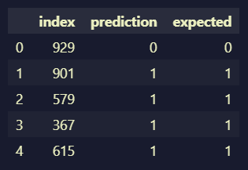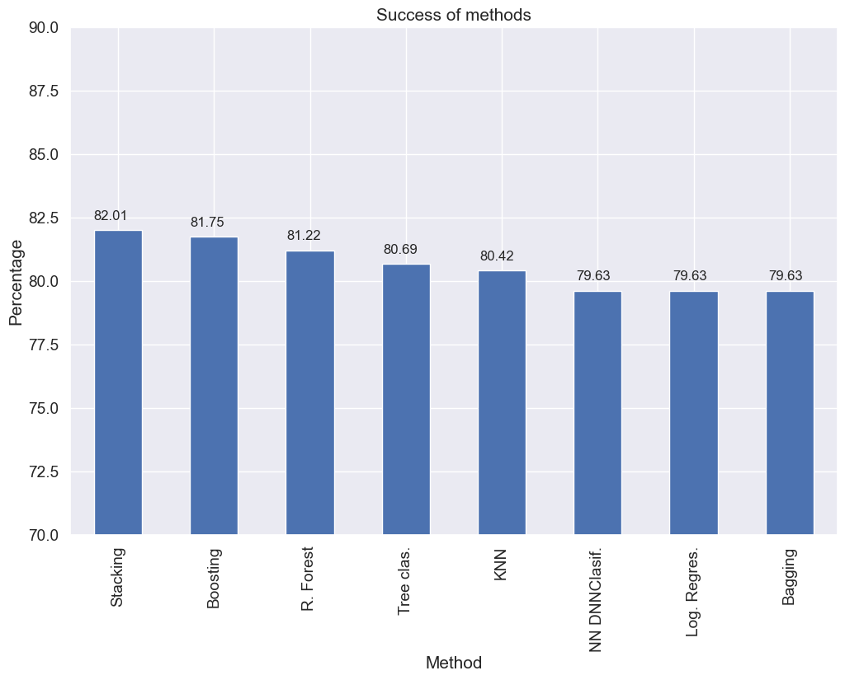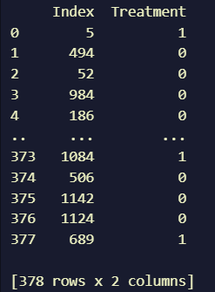

**8. ADVANTAGES & DISADVANTAGES**

**Advantages:**

* **Early Intervention:** Identifying potential mental health issues early allows for timely intervention, reducing the severity of problems and improving the chances of successful treatment.
* **Improved Well-Being:** By proactively addressing mental health concerns, employees are more likely to receive the support and resources they need, leading to improved mental well-being and job satisfaction.
* **Enhanced Productivity:** A healthier and more mentally balanced workforce is likely to be more productive, reducing absenteeism and increasing job performance.
* **Cost Reduction:** Addressing mental health issues early can lead to cost savings for organizations by reducing healthcare expenses, employee turnover, and the need for temporary replacements.
* **Data-Driven Insights:** Machine learning models can provide valuable insights into the factors that contribute to mental health issues, helping organizations make informed decisions regarding employee support programs and work arrangements.
* **Ethical and Inclusive:** A well-implemented solution respects data privacy, consent, and employee rights, promoting ethical and inclusive practices in the workplace.

**Disadvantages and Challenges:**

* **Privacy Concerns:** Collecting and analyzing personal data to predict mental health issues raises concerns about employee privacy, and mishandling data can lead to ethical and legal issues.
* **Bias in Data:** If the data used to train the model is biased or incomplete, it can result in a biased predictive model that may disproportionately impact certain demographic groups.
* **False Positives and Negatives:** Predictive models are not infallible and can produce false positives (identifying issues that aren't present) or false negatives (missing real issues), which may lead to unnecessary stress or undetected problems.
* **Employee Resistance:** Some employees may be uncomfortable with the idea of their mental health being predicted and may resist using such a system, fearing stigmatization or discrimination.
* **Cost and Resource Intensive:** Developing, implementing, and maintaining a predictive model can be resource-intensive, requiring investments in technology, data management, and employee training.
* **Depersonalization:** Relying solely on a predictive model may depersonalize the approach to mental health, potentially neglecting the importance of personal interactions and support.
* **Data Security:** Ensuring the security of sensitive employee data is crucial, and data breaches can have severe consequences for both individuals and organizations.
* **Legal Compliance:** Navigating the evolving legal landscape related to mental health and data privacy can be complex and challenging, requiring organizations to stay compliant with regulations.

**9. CONCLUSION**

The project "Predicting Mental Health Illness of Working Professionals Using Machine Learning" represents a crucial step toward addressing the pressing issue of mental health in the modern workplace. It has explored the development of a predictive model that aims to identify potential mental health issues among working professionals, enabling early detection, intervention, and support

**10. FUTURE SCOPE**

The project on predicting mental health issues in working professionals using machine learning has promising future prospects that extend beyond its initial implementation. Here are some key areas where the project's scope can evolve:

* **Advanced Machine Learning Techniques:** Continuous advancements in machine learning and artificial intelligence will provide opportunities to develop more sophisticated and accurate predictive models. Deep learning and natural language processing (NLP) may play a significant role in improving the precision of predictions.
* **Real-Time Monitoring:** Future applications may involve real-time monitoring of employees' mental health, using wearable devices, chatbots, and other technology to provide instant support and intervention.
* **Personalized Mental Health Support:** Predictive models can be tailored to provide personalized mental health recommendations and support based on an individual's unique needs and risk factors.
* **Integration with Telemedicine:** As telemedicine continues to grow, integrating predictive models with telehealth services can offer immediate access to mental health professionals for employees at risk.
* **Remote Work Considerations:** With the rise of remote work, predictive models can adapt to the unique challenges and stressors associated with virtual work environments.
* **Global Adoption:** The project's success can lead to its adoption on a global scale, as organizations worldwide recognize the importance of employee mental health and well-being.
* **Mental Health in Other Sectors:** The knowledge and experience gained from this project can be applied to other sectors, such as healthcare, education, and public services, to address mental health concerns in a broader context.
* **Policy and Regulation:** The project can contribute to the development of workplace policies and regulations related to mental health, data privacy, and ethical data usage.
* **Mental Health Research:** Data collected and analyzed through predictive models can be valuable for mental health research, contributing to a better understanding of the factors influencing mental well-being.
* **Public Awareness:** As the use of predictive models becomes more prevalent, it can contribute to reducing the stigma surrounding mental health issues and raise public awareness about the importance of early intervention.
* **Ethical AI in the Workplace:** The project's emphasis on ethical considerations can set a standard for responsible AI use in the workplace, influencing the development of ethical guidelines for AI and data analytics.
* **Human-Machine Collaboration:** Future applications may involve a deeper integration of human expertise and AI, ensuring a balanced approach to mental health support that combines the strengths of both.

**11. APPENDIX**

**GitHub Link**

https://github.com/smartinternz02/SI-GuidedProject-600351-1697604027/blob/main/mental_health_treatment_prediction_using_machine_learning.ipynb